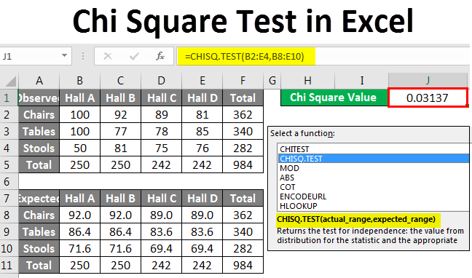

Chi Square Test in Excel
Chi Square Test in Excel is one such statistical function which is used to calculate the expected value from a dataset which has observed values. Excel is a versatile tool to analyze data visually as well as statistically. It is one of the few spreadsheet tools around which supports advanced statistical functions. Using these functions, we can gain insights from a dataset which may not be possible by just visually analyzing them. In this article, we will learn how to calculate the Chi Square from a database using excel. Before going into detail with the Chi Square Test, let us go through a few examples.
Chi Square Test is a test of the validity of a hypothesis. The Chi Square P Value tells us if our observed results are statistically significant or not. A statistically significant result means that we reject the null hypothesis (null hypothesis in statistics is a statement or hypothesis which is likely to be incorrect). A Chi Square P Value is a number between 0 and 1. A Chi Square P Value less than 0.05 usually lead to rejection of the null hypothesis.

How to do Chi Square Test in Excel?
Let’s understand how to do the Chi Square Test in Excel with some examples.

Example:
Chi Square test can tell us whether the proportion of a given number of items is in one place based on a random sample are statistically independent of each other or not.
Suppose your company has 10000 pieces of furniture. About one by tenth of them are distributed over four halls. We can find out what proportion of the total furniture is in one hall as shown below:
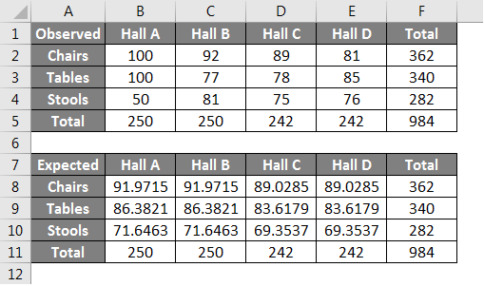
Observe that we have about 250 pieces of furniture in each hall. If we want to get the expected number of furniture by type, we will calculate it as follows:
Expected Value = Category Column Total X (Category Row Total/Total Sample Size)
Using this formula, we get an expected number of about 92 Chairs in Hall A as follows:
Expected Number of Chairs in Hall A = 250 X (362/984)
We will check the difference using the following formula:
((Observed Value-Expected Value)ⁿ) / expected value
In the case of Chi Square test, n = 2
This statistic has an approximate Chi Squared distribution if each quantity is independent of the other. The degree of freedom for each quantity would be determined by the following formula:
(number of rows – 1) X (number of columns – 1)
Which in this case is 6.
We find the Chi Square P value for the first value that is the number of chairs. The null hypothesis is that the location of the furniture is independent of the type of furniture.
The above example can be analyzed using the CHISQ.TEST Function to get the Chi Square value directly and check if our assumption that the location of the furniture is independent of the type of furniture is correct or not. In this case:
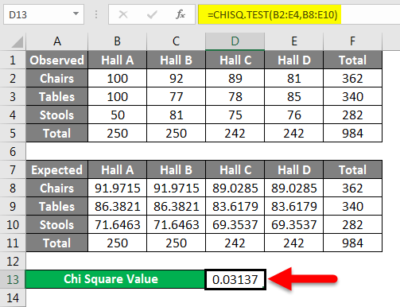
The Chi Square value is approximately 0.03. From our earlier discussion, we now know that this rejects the null hypothesis. So our null hypothesis assumption that the location of the furniture is independent of the type of furniture is not correct.

